# Simulations

After components selected their model implemented in LTspice and simulations test applied under given condition.

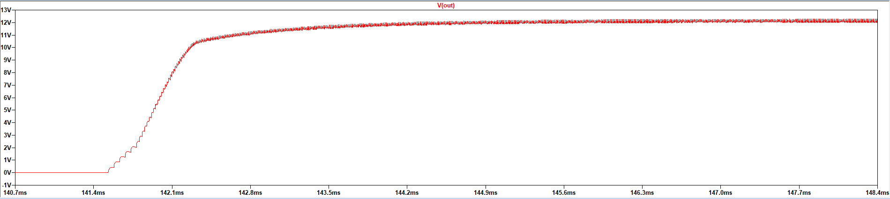

Figure 3: Output voltage waveform

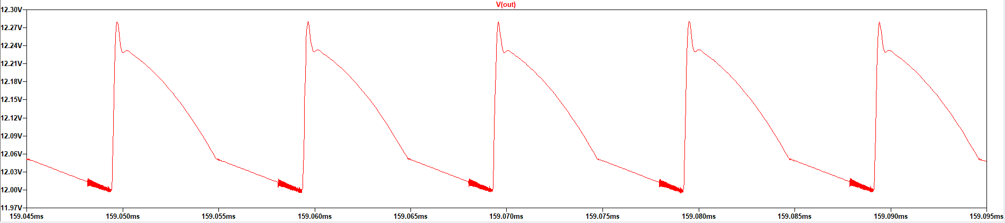

Figure 4: Output voltage close view waveform

As seen in the figure 3 after system turn on output voltage increase to the 12 V and give stable output voltage. Figure 4 shows ripple of output voltage and it is 0.28 V so output voltage ripple ratio is 2.33% and it is appropriate for project requirements.

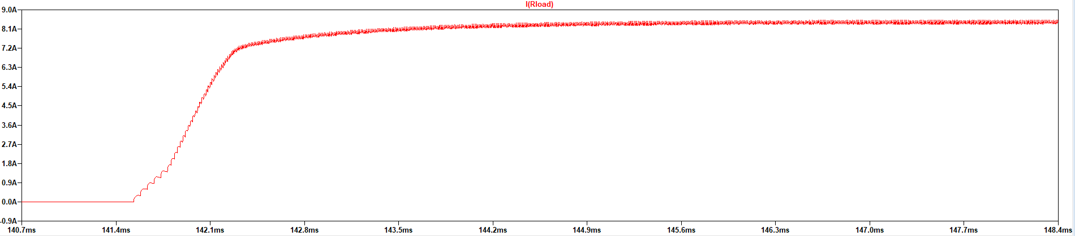

Figure 5: Output current waveform

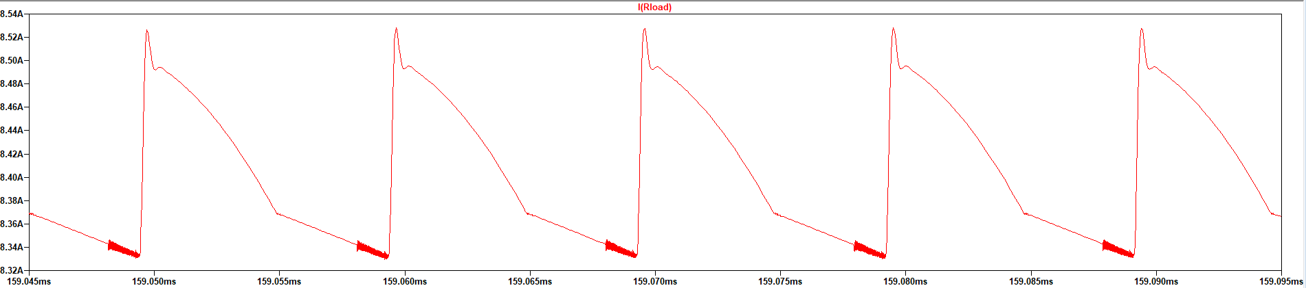

Figure 6: Output current close view waveform

In simulation tested load taken as fully resistive component and it is 1.44Ω so output current waveforms same as voltage and output power 101.15 W and it is little exceeding our rated power.

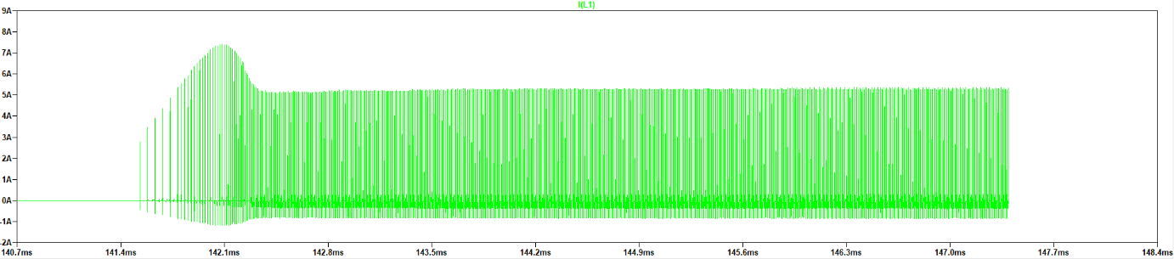

Figure 7: Primary inductor current waveform

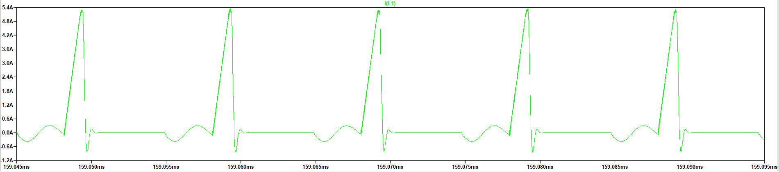

Figure 8: Primary inductor current close view waveform

When we look at the figure 7 its seen that initially current increase up to 7.5A then it is settled at 5.2A because initially output voltage is zero and system have to charge output capacitance and feedback system of the controller increase duty cycle and this result higher primary current. At figure 8 triangular shape of inductor current seen at mosfet on.

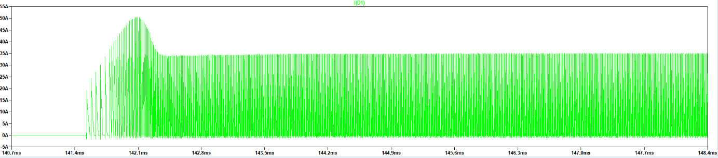

Figure 9: Secondary inductor current waveform

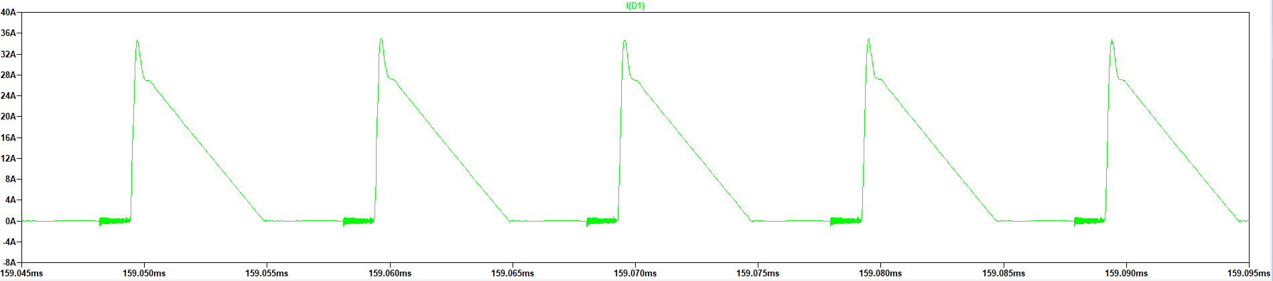

Figure 10: Secondary inductor current close view waveform

Secondary part of transformer has higher current density and its pulsative current reach 50 A at initial time then it is fixed at 35A.

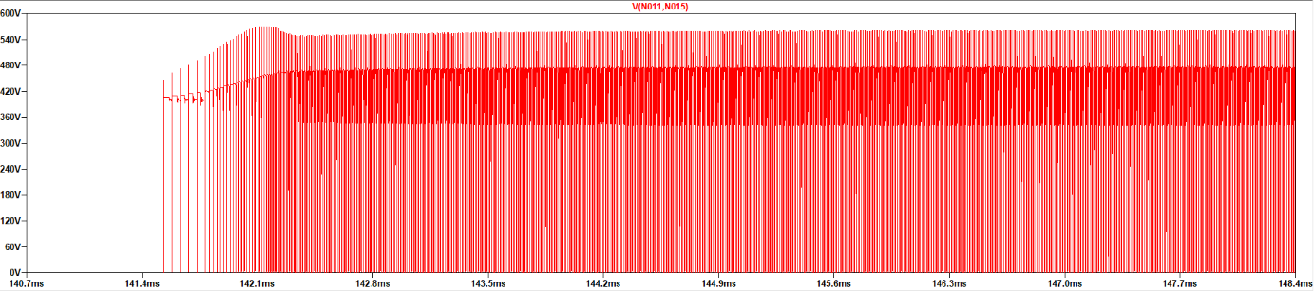

Figure 11: Mosfet voltage waveform

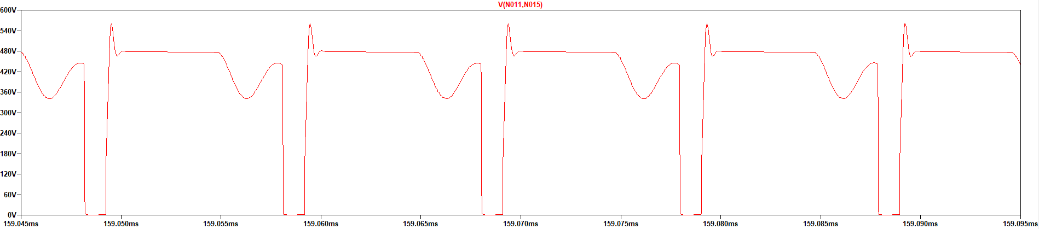

Figure 12: Mosfet voltage close view waveform

Selected mosfets breakdown voltage is 700 V and as seen in the figure 12 its voltage jump to the 560V when it is turn of because of the leakage inductance then it decrease to the 478V. At Ddwell time its voltage oscillate. When looked at the figure 9 and 11 their in the our mosfets operation region.

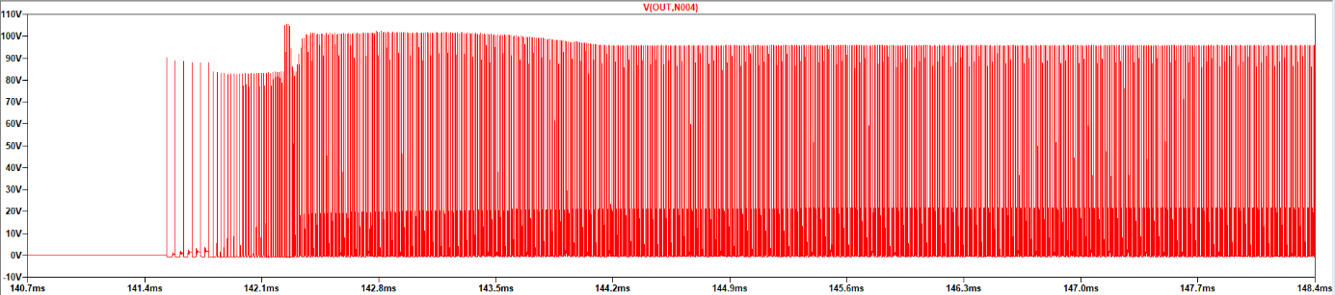

Figure 13: Diode voltage waveform

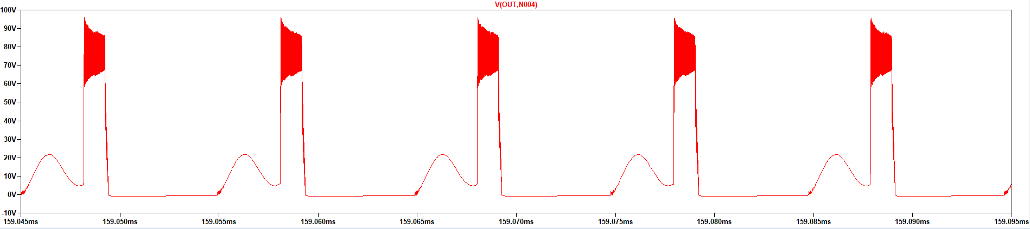

Figure 14: Diode voltage close view waveform

Selected diode breakdown voltage is 250 V and it can operate this voltage ratios. Diodes continuous current 40 A and as figure 9 shows secondary sides current reach 50 A initially but it is pulsative current and diode can operate pulsative current up to 80 A.